CS 1632 - DELIVERABLE 3

Josh Demusz - joshdemusz

Github: https://github.com/joshdemusz/CS1632-D3

Description of Issues

The biggest issue I had with this deliverable was getting everything set up, and learning how to use the new tools we were required to learn. For example, I had to learn how to use the Selenium IDE in Firefox (a browser that I am not used to) as I worked. Also, I had to get more familiar with the ability to “inspect” a webpage in order to analyze its structure. This was a very helpful skill when writing tests.

When writing the tests in particular, my main issue was determining how to compare the observed and expected values for the Factorial and Fibonacci function. For these functions, I had trouble finding the number that the two respective functions calculate and return to show to the user. However, I eventually decided that it would be easiest to compare the observed String that was outputted from both functions with the expected String.

**Tests that failed:**

TestHomepage.java:

testText1(): Tests to make sure that the String 'Welcome, friend, to a land of pure calculation' appears on the homepage.

TestFactorial.java:

testTextInput(): Tests to make sure that text input into the Factorial function is properly handled.

testDecimalInput(): Tests to make sure that decimal input into the Factorial function is properly handled.

testBlankInput(): Tests to make sure that blank input (“”) into the Factorial function is properly handled.

TestFibonacci.java:

testTextInput(): Tests to make sure that text input into the Fibonacci function is properly handled.

testIntegerInput31(): Tests to make sure that when the integer 31 is entered into the Fibonacci function, the correct output is shown.

testUpperBoundaryInput(): Tests to make sure that when the integers 100 and 101 are entered into the Fibonacci function, the correct output is shown.

testDecimalInput(): Tests to make sure that decimal input into the Fibonacci function is properly handled.

testBlankInput(): Tests to make sure that blank input (“”) into the Fibonacci function is properly handled.

testIntegerInput(): Tests to make sure that the Fibonacci function calculates the correct value given the inputted integer.

Screenshot

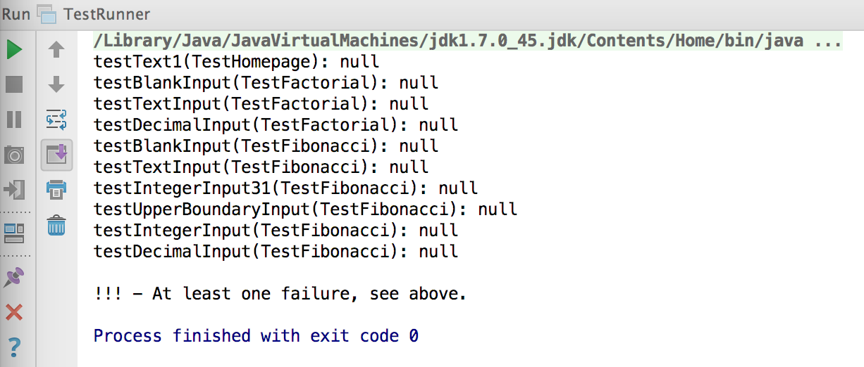

Defects

Summary: When a decimal is entered into the Factorial function, an internal server error occurs.

Description: If a decimal is inputted into the Factorial function on the Factorial page, an internal server error occurs. No String is displayed to the user, and the user is not able. For the Factorial function, all-invalid input should be properly handled, as per the requirements.

Reproduction steps: Enter .1 into the Factorial function text-entry bar. Click the “Submit” button.

Observed behavior: An internal server error occurs.

Expected behavior: The String ‘Factorial of .1 is 1!’ is returned.

Summary: When nothing is entered into the Factorial function, an internal server error occurs.

Description: If a nothing is inputted into the Factorial function on the Factorial page, an internal server error occurs. No String is displayed to the user, and the user is not able. For the Factorial function, all-invalid input should be properly handled, as per the requirements.

Reproduction steps: Click “Submit” on the Factorial page, without entering anything into the Factorial function text-entry bar.

Observed behavior: An internal server error occurs.

Expected behavior: The String ‘Factorial of is 1!’ is returned.

Summary: When a String is entered into the Factorial function, an internal server error occurs.

Description: If a String is inputted into the Factorial function on the Factorial page, an internal server error occurs. No String is displayed to the user, and the user is not able. For the Factorial function, all-invalid input should be properly handled, as per the requirements.

Reproduction steps: Enter ‘AH’ into the Factorial function text-entry bar. Click the “Submit” button.

Observed behavior: An internal server error occurs.

Expected behavior: The String ‘Factorial of AH is 1!’ is returned.

Summary: When a decimal is entered into the Fibonacci function, an internal server error occurs.

Description: If a decimal is inputted into the Fibonacci function on the Fibonacci page, an internal server error occurs. No String is displayed to the user, and the user is not able. For the Fibonacci function, all-invalid input should be properly handled, as per the requirements.

Reproduction steps: Enter .1 into the Fibonacci function text-entry bar. Click the “Submit” button.

Observed behavior: An internal server error occurs.

Expected behavior: The String ‘Fibonacci of .1 is 1!’ is returned.

Summary: When nothing is entered into the Fibonacci function, an internal server error occurs.

Description: If a nothing is inputted into the Fibonacci function on the Fibonacci page, an internal server error occurs. No String is displayed to the user, and the user is not able. For the Fibonacci function, all-invalid input should be properly handled, as per the requirements.

Reproduction steps: Click “Submit” on the Fibonacci page, without entering anything into the Fibonacci function text-entry bar.

Observed behavior: An internal server error occurs.

Expected behavior: The String ‘Fibonacci of is 1!’ is returned.

Summary: When a String is entered into the Fibonacci function, an internal server error occurs.

Description: If a String is inputted into the Fibonacci function on the Fibonacci page, an internal server error occurs. No String is displayed to the user, and the user is not able. For the Fibonacci function, all-invalid input should be properly handled, as per the requirements.

Reproduction steps: Enter ‘AH’ into the Fibonacci function text-entry bar. Click the “Submit” button.

Observed behavior: An internal server error occurs.

Expected behavior: The String ‘Fibonacci of AH is 1!’ is returned.

Summary: The calculated Fibonacci numbers are shifted to left.

Description: The Fibonacci numbers are not calculated correctly. For valid input, the number that is returned from the Fibonacci function is the Fibonacci number of input+1. In other words, the returned Fibonacci numbers are incorrectly shifted to the left.

Reproduction steps: Enter 5 into the Fibonacci function text-entry bar. Click the “Submit” button.

Observed behavior: The String ‘Fibonacci of 5 is 8!’ is returned.

Expected behavior: The String ‘Fibonacci of 5 is 5!’ is returned.

Summary: For integer input above 30 (31-100), a ‘1’ is returned for the Fibonacci number.

Description: If a valid integer value greater than 30 (31-100) is inputted into the Fibonacci function on the Fibonacci page, a ‘1’ is returned for the Fibonacci number. ‘1’ should only be returned if the Fibonacci number is actually 1, or if the input was invalid. Since the integers from 31-100 fall in neither of these categories, this is a defect based on the given requirements.

Reproduction steps: Enter 31 into the Fibonacci function text-entry bar. Click the “Submit” button.

Observed behavior: The String ‘Fibonacci of 31 is 1!’ is returned.

Expected behavior: The String ‘Fibonacci of 31 is 1346269!’ is returned.

**(More of a concern than a defect)**

Summary: Correct text appears, but is split between two elements.

Description: The text ‘Welcome, friend, to a land of pure calculation.’ appears on the homepage. However, it fails the test because it is divided between two elements. Based on the requirement, this does not seem to be an issue since the text appears as one String on the webpage. However, I included this defect just incase.

Reproduction steps: Open the home page link of the website. Or go to the base URL of the website.

Observed behavior: The String ‘Welcome, friend, to a land of pure calculation.’ Is displayed on the homepage.

Expected behavior: The String ‘Welcome, friend, to a land of pure calculation.’ Is displayed on the homepage, but is divided between two elements.